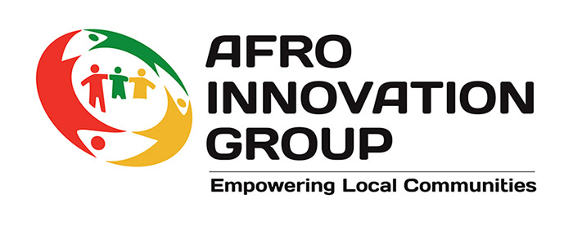 | 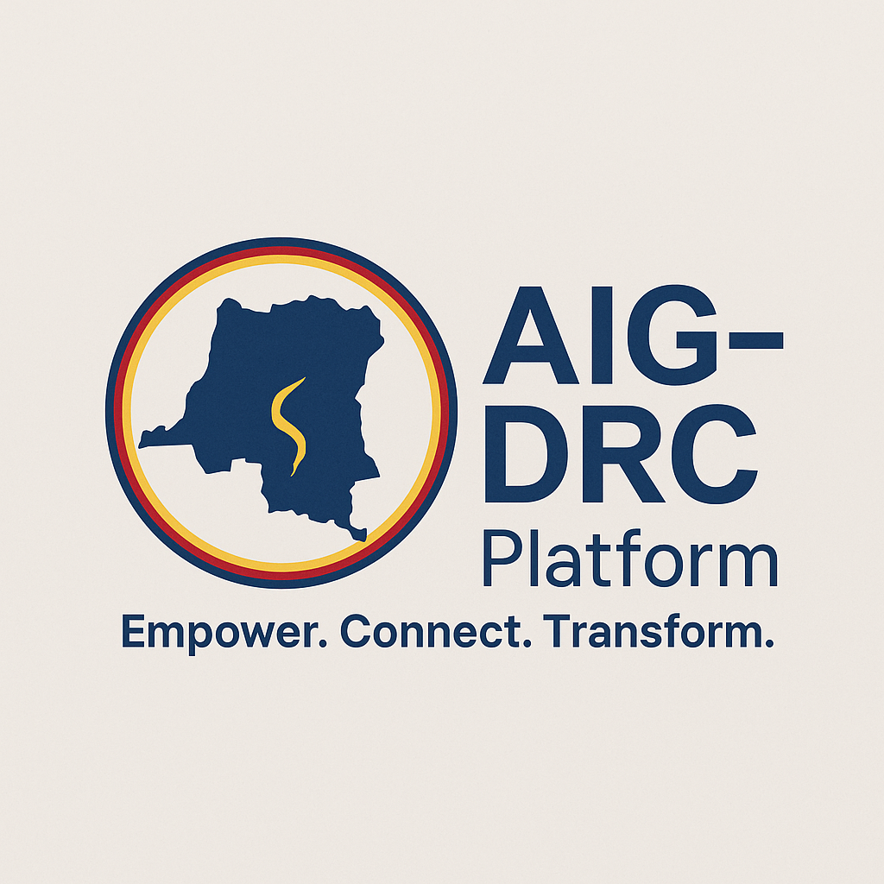

Afro Innovation Group (AIG) Contribution to Women, Peace and Security (WPS)

Brief Summary of AIG’s Work with Women (by Country)

Afro Innovation Group (AIG) is a refugee-, asylum seeker-, and migrant-led organisation with over 20 years of experience working across the United Kingdom and internationally. Founded in Leicester, AIG empowers displaced and marginalised communities—particularly women and youth—through rights-based support, community leadership, and inclusive development. In 2024, AIG launched the AIG-RDC Platform in the Democratic Republic of Congo, formalising its grassroots partnerships in fragile and conflict-affected regions.
AIG’s mission is to support communities to overcome structural inequalities and realise their full potential through inclusive, locally driven action. Our vision is a world where displaced people and migrants are safe, included, and leading solutions to the challenges they face.
Across all our projects, women’s empowerment, protection, and participation are central pillars—whether through mental health programmes in Leicester, trauma recovery in conflict zones, or women-led farming cooperatives in East Africa. This document outlines our contributions to the Women, Peace and Security (WPS) agenda in the UK and internationally.
United Kingdom
AIG’s work with women in the UK centres on trauma recovery, integration, empowerment, and systemic change. Through the Women Together programme, we provide holistic support to migrant and refugee women—covering translation, mental health, domestic violence advocacy, employment, education, and benefits navigation. Our Arts & Music for Women projects offer healing spaces for racialised women disproportionately affected by mental health stigma and systemic neglect. We work in partnership with domestic violence organisations such as FREEVA, Women and Girls Network, and Women’s Aid to offer legal support and life-saving advocacy. Our mental health initiatives—funded by the NHS and local councils—include peer-led support groups, befriender programmes, and trauma-informed workshops. We also assist women returning to work after care responsibilities through retraining, business development, and leadership support. Dozens of women have gone on to establish community groups, open businesses, or join AIG’s governance and volunteer structure—transforming from survivors into civic leaders.
Democratic Republic of Congo (DRC)
AIG-RDC operates as a locally registered platform working across conflict-affected provinces. Our interventions address the compounded effects of war, displacement, and gender-based violence. Through the Women of Resilience programme, we support survivors of sexual violence, wrongful imprisonment, and exploitation. Legal aid is delivered in partnership with a Kinshasa-based law firm, with fieldwork conducted in eastern DRC’s IDP camps. We coordinate with over 13 local partners to offer health services, advocacy, security, and livelihoods training. Women-led farming cooperatives have been established on 11 hectares of acquired land, enabling survivors to rebuild economic agency. Additional support includes beauty and healthcare training, trauma counselling, and political participation workshops. AIG-RDC fills the critical gap left by withdrawn international actors—mobilising local and diaspora-led leadership for protection and long-term peacebuilding.
Afghanistan
In Afghanistan, AIG works with British-Afghan women to support home-based education, digital skills, and cottage industries. Through Digital Partnership Hubs, women access training, health education, and peer support networks—mostly via WhatsApp. After on-site visits in April and August 2025, we are expanding engagement through the Gulbahar Foundation and other local actors to build sustainable, women-led economic alternatives and increase access to healthcare and education.
Zanzibar and Tanzania
AIG partners with Asma Mwinyi Foundation and Al Fattah Foundation to support homeless and vulnerable women in displacement camps. Activities include food banks, legal aid clinics, housing assistance, and employability workshops. With support from mosque networks and faith-based partners, we also run trauma counselling and protection services for women facing abuse.
Kenya
In rural coastal areas and Nairobi informal settlements, AIG delivers legal support, healthcare, skills training, and community building for women affected by police violence and poverty. We partner with local organisations to deliver trauma counselling, small business support, and safe housing for displaced and rough-sleeping women.
Nigeria
In collaboration with HEM Foundation, AIG delivers trauma support, employment training, and organisational leadership development. Some officers have participated in UK-based skills exchange under the Tier 5 Charity Visa route. AIG is working with new Nigerian partners to build a community-based network aimed at reducing irregular migration and enhancing local livelihoods.
Pakistan and India
In partnership with Al Khidmat Foundation, AIG supports women’s access to education and healthcare, particularly in the Swat Valley and North-West Frontier Province. Activities focus on leadership development, gender equality, and post-disaster resilience.
Morocco and Sahel Region
AIG’s presence in Morocco, Algeria, Tunisia, and Libya is coordinated by Houda, a part-time staff member. During the Moroccan earthquake, rapid volunteer mobilisation supported emergency services and women-led grassroots responses. Ongoing work includes trauma care, hygiene kits, and frontline training for new volunteers.
Egypt and Sudan Border
AIG partners with Al Risala and the Sudanese women-led umbrella MANSAM to provide emergency aid to women displaced by the civil conflict. Services include healthcare access, shelter, and advocacy for women and children at the Egypt–Sudan border. MANSAM is supported by UN Women and the Norwegian Refugee Council.
Emerging and Expanding Locations
In countries including Guinea, Cameroon, Ghana, Uganda, Zimbabwe, Mozambique, Angola, Malawi, Senegal, Mali, Bangladesh, and South Africa, AIG is building new partnerships focused on gender-based violence, health access, women’s cooperatives, and civic leadership. Work in Malawi and Bangladesh is particularly promising, with early-stage training, advocacy, and peer-led service models being piloted.

