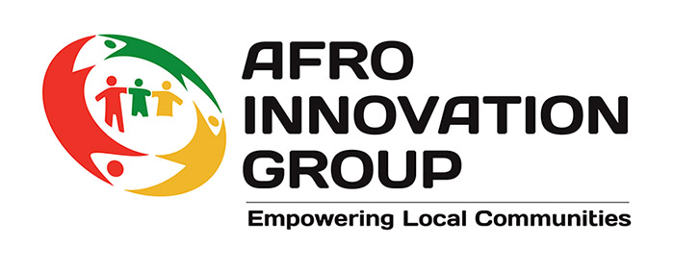

Privacy Notice
This privacy notice explains how Afro Innovation Group (“we”, “us”, or “our”) collects, uses, and protects your personal information, and your rights under data protection law.
We are committed to being transparent about how we use personal data and to complying with the UK General Data Protection Regulation (UK GDPR) and the Data Protection Act 2018.

1. Who We Are
Afro Innovation Group is a UK-based charity providing community support, advice, advocacy, safeguarding, and wellbeing services.
Contact details:
Afro Innovation Group
Floor 6, 60 Charles Street
Leicester, LE1 1FB
Email: leicester1@afroinno.org
Telephone: 0116 208 1340
If you have any questions about this privacy notice or how we use your data, please contact us using the details above.

2. The Personal Data We Collect
We may collect the following types of personal information:
- Name, address, email address, and telephone number
- Date of birth, nationality, and immigration or residency information (where relevant)
- Health, disability, safeguarding, or wellbeing information (where necessary)
- Case notes, referrals, assessments, and support records
- Employment, volunteering, or training details
- Feedback, complaints, and monitoring information
Some of this information may be special category data, which receives extra protection under the law.

3. How We Use Your Personal Data
We use your personal data to:
- Provide advice, advocacy, and support services
- Safeguard children and vulnerable adults
- Communicate with you about our services and activities
- Comply with legal, regulatory, and funding requirements
- Monitor outcomes and improve our services
We only use your data for purposes that are lawful, fair, and transparent.

4. Lawful Basis for Processing
Under UK GDPR, we must have a lawful basis for processing your data. These may include:
- Consent – where you have given clear permission
- Legal obligation – where we are required by law
- Vital interests – to protect someone’s life
- Public task – where we carry out functions in the public interest
- Legitimate interests – where processing is necessary for our charitable purposes
For special category data, we rely on explicit consent or safeguarding and substantial public interest conditions.

5. Who We Share Your Data With
We may share your information with trusted partners where necessary and lawful, including:
- Local authorities and statutory services
- NHS and health partners
- Legal or safeguarding authorities
- Funders (in anonymised or aggregated form only)
We do not sell your personal data or share it for marketing purposes.

6. How Long We Keep Your Data
We keep personal data only for as long as necessary for the purpose it was collected, in line with our data retention policies, legal requirements, and funding obligations.

7. Your Data Protection Rights
You have the right to:
- Access your personal data
- Request correction of inaccurate or incomplete data
- Request erasure of your data, in certain circumstances
- Request restriction of processing
- Object to processing in certain circumstances
- Withdraw consent at any time, where consent is the lawful basis
You also have the right to complain to the Information Commissioner’s Office (ICO) if you are unhappy with how we handle your data:
www.ico.org.uk

8. How We Keep Your Data Secure
We use appropriate technical and organisational measures to protect personal data against loss, misuse, unauthorised access, or disclosure.

9. Cookies and Website Use
Our website may use cookies to help it function properly and improve user experience. You can manage cookies through your browser settings.

10. Changes to This Privacy Notice
We may update this privacy notice from time to time. The most recent version will always be available on our website.

